Minnesota Education and Training Voucher
Online Application Instructions

Notes about the ETV application
- Applicants have 4 hours to complete and submit or save the application. The time is on each page of the application. Note: If the time does not change, the application maybe disconnected from the internet and it cannot be submitted or saved. Print what is entered, exit the application and start the application again.
- All questions on the application are required and must be answered.
- Click on ETV Expense Guidelines box on the first and budget pages to open and review.

Get an application
Open the ETV website and click on the ‘Apply’ tab and then ETV online application to open the landing page below. The application starts on the landing page.
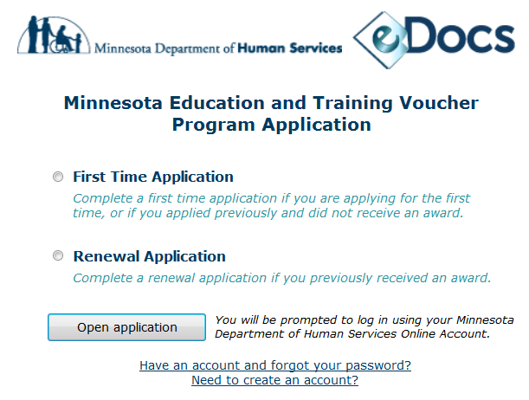
Create a username and password: All applicants must have a username and password to login to the application. Applicants will go to a separate window on the Minnesota Department of Human Service’s website. The ETV application is not on this website so do not start an application from this page.
First Time Applicants:  - On the landing page, select ‘First Time Application’ if you are applying for the first time or applied previously and did not receive an award.  - Do not complete a renewal application.  - Click on ‘If you are a first time user, click here to register’ to go to the registration website.  - Complete the registration, exit the website and return to the ETV application landing page.  - Keep your username/password as it is needed to enter your application every year you apply for the program. ETV staff does not know and cannot get your username/password.  - Click ‘First Time Application’ and ‘Open application’ | Renewal Applicants:  - On the landing page, select ‘Renewal Application’ if you previously received an award.  - Do not complete a first time application.  - If you do not remember your username or password, click on ‘If you do not have a username or password, even though you have received an ETV award in the past, click here to register’ or ‘Have an account and forgot your password?’  - Complete the registration, exit the website and return to the ETV application landing page.  - Keep your username/password as it is needed to enter your application every year you apply for the program. ETV staff does not know and cannot get your username/password.  - On the landing page, click “Renewal Application’ and ‘Open application’.
Login to the application. All applicants: Enter your username/password and click ‘Login’. There are two issues with logging into the application.
Issue 1: A message appears that your username/password are incorrect or not recognized.
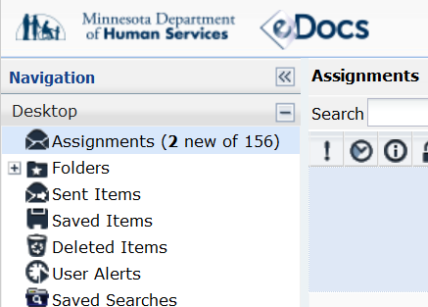
Resolution: Exit the application. It can take up to six hours for the computer system to register your username and password after you create an account.

Issue 2: This eDocs Navigation screen appears.
Resolution:
- Exit the screen to return to the landing page. Do not take any action on this screen. It is not part of the application.
- On the landing page, click on ‘First Time’ or ‘Renewal’ application and then ‘Open application’.
- If the application does not appear, repeat the step.

Start the application
Page 1: Application Type and Eligibility Criteria: Students must meet the eligibility criteria to apply or reapply to the ETV program. No exceptions to the criteria are made.

First time applicants:  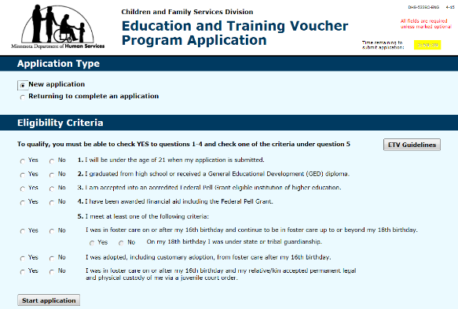  - Select ‘New application’ if starting an application or ‘Returning to complete an application’ if an application was previously started and saved.  - Complete the eligibility section, and click ‘Start application’. | Renewal applicants:  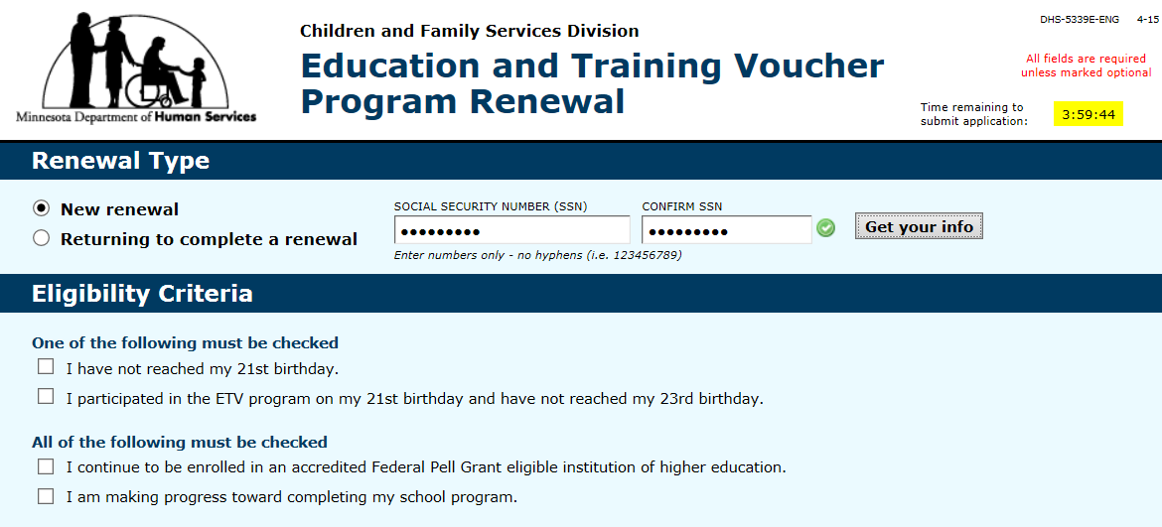  - Select ‘New application’ if starting an application’ or ‘Returning to complete an application’ if an application was previously started and saved.  - When either is selected, two Social Security Number boxes appear. Enter your Social Security Number in both boxes.  - A green check mark will appear. Click on it and a ‘Get your info’ box will appear.  - Click on ‘Get your info’ and your previous application information will fill in this one.  - Complete the ‘Eligibility Criteria’ section and click on ‘Start renewal’.
Page 2: Student Information: All applicants answer or update all questions.
Page 3: Placement History
First time applicants:  - Answer all questions.  - Under heading ‘My social worker or probation office is:’ Add the staff person from the county/tribal agency responsible for your placement, even if you left care.  - When first time ETV applications are submitted, this worker is immediately sent an automated email with instructions to complete an online Verification of Eligibility form.  - If you do not have a current worker, contact the agency to get a name and email address to add to your application. Incorrect email addresses delay determining ETVs. |  | Renewal applicants:  - Update all questions.  - Students not in foster care must add a worker’s name and email address as it is a required field. The email address can be any address as it is not used by the ETV program.
Page 4: Post-secondary Education: All applicants answer or update all questions, including the correct date for the ‘Anticipated Graduation/Completion Date’. It is used to determine ETVs.
Page 5: Essay
First time applicants: Answer all essay questions. |  | Renewal applicants:  - Students completing their first renewal application, have their first time application essay auto-fill into this section. The renewal application questions are different and must be answered.  - Applicants not updating their essays will be asked to, and it may delay determining ETVs.
Page 6: Authorization and agreement: All applicants read the documents and follow instructions.
- Authorization for Release of Information describes the information that can be shared about you. If you approve, check the authorization button.
- Participation Agreement outlines your responsibilities as an ETV participant. If you approve, check to agree.
- Click on the Notice of Privacy Practice button to open the form. Review how private information about you and your participation in the ETV program may be used and disclosed, and how you can obtain your information.
Page 7: School year budget: All applicants do the following.
- School Year Budget: Check all months you plan to attend school during the ETV award year of July 1-June 30. The months should match the school start and anticipated graduation dates in the post-secondary education section.
- Expense section:
  - Click on ETV Expense Guidelines to open the document to review. The guidelines list all of the expenses ETVs pay for and rules for each expense.
  - Click on the name of each expense to open an informational message/definition. Review before adding amounts for each expense.
  - Add the total amounts for each expense for the time period identified under expense headings, such as ‘Only for the months attending school’ under the Post-Secondary School Expense heading and ‘For the entire ETV award year’ under the Housing and Personal Expenses heading.
  - Add only the expenses that occur during the award year (either July 1 or Jan. 1 to June 30).
  - Medical insurance is not paid by ETVs. Students can apply for the Affordable Care Act.
  - Transportation expenses appear only if ‘Off Campus’ housing type is selected.
  - Car related expenses appear only if ‘Car’ is selected.
  - Extended foster care living settings:
- Students living in foster homes have the option to add the amounts for rent deposit, rent, utilities, and food to their budget. The total amount of their expenses will be considered when determining their ETVs.
- Students in supervised independent living settings, such as a dorm or apartment, must add the amounts for rent deposit, rent, utilities, and food to their budget. The total amount of their expenses will be considered when determining their ETVs.
- Financial aid section:
- Click on the financial aid type for information or to go to a website.
- Extended foster care living settings:
- Students living in foster homes who did not add amounts for rent deposit, rent, utilities, and food to their budget, should not add the amount of the Basic Monthly Foster Care Maintenance and Foster Care Supplemental amounts on their budget.
- Students in supervised independent living settings must add Basic Monthly Foster Care Maintenance and Foster Care Supplemental, if received, amounts on their budgets.
- Financial aid awarded and not listed on the budget should be added in the ‘Other’ section.
- Students under state/tribal guardianship and awarded tuition waivers, add the amount in the tuition waiver box.
Page 8: Attachments: All applicants do the following.
- Attach only the documents listed on the application. Substitute documents will not be accepted.
- Click on ‘Manage Attachments’ for the ‘Attachment Manager’ screen to appear. Click on ‘Add File’ and ‘Browse’ to the location of the saved documents and attach each document.
- Click ‘Finish’ when all documents are attached and return to the application.
- Department ETV staff must be able to read the documents attached.
- Attaching incorrect documents or those that cannot be opened/read will delay determining ETVs.
Page 8: Submit or Save Application: All applicants do the following.
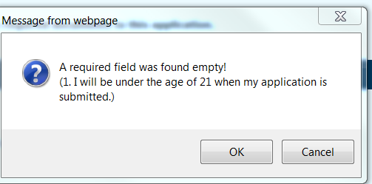
- Check either ‘I am the applicant’ or ‘I am the parent/guardian’, and ‘Print Form’.
- If a required question was not answered, a message box will appear with the question. Answer the question and return to this page to submit or save the application.

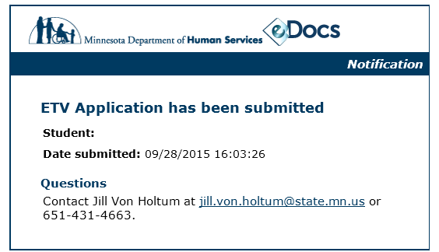
- Submit Final Application if applications are complete.
  - Applicants are immediately sent this automated confirmation email.
  - Do not return to submitted applications to correct or add information as it will create a second submitted application. Contact department ETV staff to make additions, corrections and/or attach documents.
  - First time applicants’ agency workers are immediately sent an automated email with instructions to complete a Verification of Eligibility form.
  - Department ETV staff does the following after applications are submitted:
    - Receives email notifications when applications are submitted, and when the Verification of Eligibility forms are sent to and submitted by agency staff.
    - Sends applicants confirmation emails that their application was received.
      - Complete applications: Students received ETV award letters.
      - Incomplete applications: Students receive instructions on completing their applications. Applications must be complete by midnight on the last day of the due date period for students to be considered for ETVs, if funds are available.
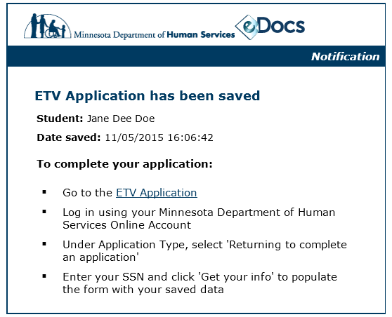
- Save Application for Later if applications are incomplete.
- Applicants are immediately sent this automated email with instructions on returning to complete their application. Department ETV staff does not receive the email and cannot assist applicants in returning to their saved applications.
  - Applications must be complete and submitted by midnight on the last day of the due date period for students to be considered for ETVs, if funds are available.

Verification of Eligibility Form
First time applicants: When first time applications are submitted, the county or tribal agency worker listed on the application, page 3: Placement History, is immediately sent this automated email with instructions to complete an online Verification of Eligibility form. The purpose of the form is for agency workers to confirm applicants’ eligibility and foster care status, even of youth not currently in foster care.
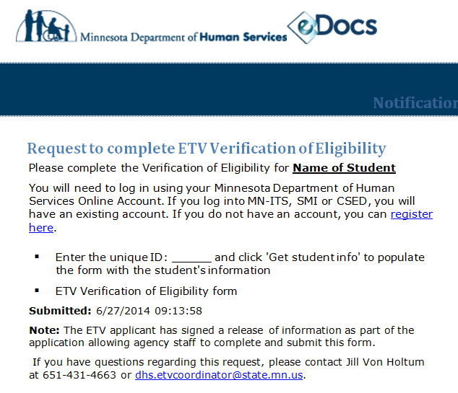
County/tribal agency staff must do the following:
  - Create or use an existing username and password to open, complete and submit the form.
  - The form must be submitted before applicants are awarded ETVs.
  - Contact department ETV staff at 651-431-4663, or Dhs.Etvcoordinator@state.mn.us, for assistance in completing the form.

Award notification
Applicants awarded ETVs are notified by email. The email contains their award letter, award worksheet and orientation information.
- Award letter: Lists the ETV award amount, the time period to use the award, and any conditions on the use of their award.
- Award worksheet: Lists expenses, financial aid and need used to determine ETV awards.
- Orientation information:
  - First time recipients receive an orientation schedule and instructions to sign up for a session.
  - Renewal recipients receive orientation information/forms.
- For students in extended foster care, their social worker is copied on the email.
- The contact person listed on the application will also be copied on the email if students checked yes to the question, “Can the contact person be included in all emails ETV staff sends to you?”
- Applicants not awarded ETVs are notified by mail of the reason(s) not awarded ETVs.

Questions: Contact Jill Von Holtum, Minnesota Department of Human Service ETV program coordinator, at 651-431-4663, or Dhs.Etvcoordinator@state.mn.us.

